# **ABSTRACT**

***Geolocation is defined as the identification/estimation of the real-world geographic location of an object, such as a radar source, mobile phone, or Internet-connected computer terminal or any other device. Apparently, geolocation involves the generation of a set of geographic coordinates and is closely related to the use of positioning systems, it is enhanced by the use of these coordinates which determine a meaningful location, such as specific area. In this project, we will be interfacing a GPS module with NodeMCU. A simple local web server is created using NodeMCU and the location details are updated in that server webpage. NodeMCU is an open source IoT platform. It includes firmware which runs on the ESP8266 module and hardware which is based on the ESP-12 module. ESP8266 can be used for geolocation by firstly obtaining nearby AP properties, and then using Google geolocation API to locate the user-device. To be able to obtain a fix on the location of the device that integrates the ESP8266 chip, we assume that the host controller first could obtain data from nearby Wi-Fi networks or cellular sub-systems. The data is consolidated into a data block that must be sent to an online geolocation API or service that will estimate the device location in terms of latitude, longitude, and accuracy.***

***Keywords***

***—***

*NodeMCU, ESP8266, GPS module, API*

**1**

**.**

**INTRODUCTION**

**Fig. 1: Geolocation symbols**

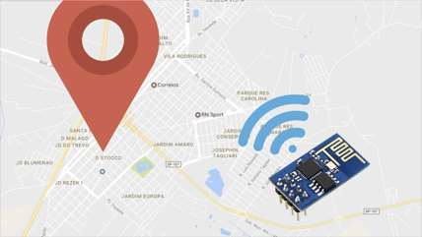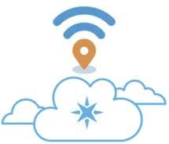

Geolocation is defined as the process of finding, determining and providing the exact location of a computer, networking device or equipment. It enables us to view the device location based on geographical coordinates and measurements.

Geolocation commonly uses Global Positioning System (GPS) and other related technologies to assess and specify geographical locations. It provides the location of a device but is generally used in a variety of applications to help locate human users. Geolocation is a technology that works through a pre-built GPS in a device that propagates the device's longitudinal and latitudinal coordinates. The coordinates are identified on a map to provide a complete address that usually includes a country, city, town/colony, building name and street address.

In this project, we will be using Breadboard, Node MCU, GPS Module, Google location API in order to track down the most precise geographical location of the entity. The Node MCU component makes the system extremely efficient and user-friendly to work with and implement.

## 2. METHODOLOGY

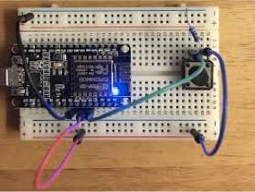

**Fig. 2: Circuit setup**

The primary goal of this project is to be able to locate the object in its most precise geographical location using the NodeMCU along with its compatible GPS Module. We will need the Blynk App which is available on both Android and iOS platform to help us send the location to the mobile via email. The Module will transmit data in multiple strings at a Baud Rate. GPS module takes some time to capture location details once it is powered on as it detects the coordinates. NodeMCU starts webserver and waits for the client to get connected. Once the client is connected to the web server, NodeMCU sends location details to the connected client via email using the BLYNK application. The location details are displayed on the app. We can track down the location using the displayed coordinates of latitude and longitude on the map.

**2.1 Hardware specification**

1. **NodeMCU**

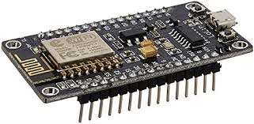

**Fig. 3: NodeMCU**

NodeMCU is an open source [Lua](https://www.lua.org/) based firmware designed for the [ESP8266 WiFi SOC from Espressif](http://espressif.com/en/products/esp8266/) and uses an on-module flash-based [SPIFFS](https://github.com/pellepl/spiffs) file system. It is implemented in C and is layered on the [Espressif NON-OS SDK.](https://github.com/espressif/ESP8266_NONOS_SDK) The firmware was initially developed as a companion project to the popular ESP8266-based [NodeMCU development modules,](https://nodemcu.readthedocs.io/en/master/(https:/github.com/nodemcu/nodemcu-devkit-v1.0)) but the project is now community-supported, and the firmware can now run on any kind of ESP module.

1. **GPS Module**

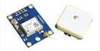

**Fig. 4: GPS Module**

The NEO-6 module series is a family of stand-alone GPS receivers featuring high-performance u-blox 6 positioning engine. These flexible and cost-effective receivers offer multiple connectivity options in a miniature 16 x 12.2 x 2.4 mm package. The compact architecture, power and memory options make the NEO-6 modules ideal for battery operated mobile devices with limited cost and space constraints. Innovative design and technology suppresses jamming sources and mitigates multipath effects which give NEO6 GPS receivers excellent navigation performance even in the most challenging environments.

**2.2 Software specifications** 1) Blynk app:

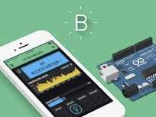

**Fig. 5: Blynk app**

Blynk is a platform for iOS and Android apps to control Arduino, Raspberry Pi, and other IoT components. It's majorly a digital dashboard where you can build a graphical interface for your project by simply dragging and dropping widgets. Blynk is not interfaced to some specific board or shield. Instead, it supports the hardware of your choice. Whether your Arduino or Raspberry Pi is linked to the Internet over Wi-Fi, Ethernet or ESP8266 chip, Blynk will get you online and ready for execution. Major IOT projects have been made using this app as it provides a user-friendly environment.

## 3. CONCLUSION

In the end, we have created a system that locates the objects exact geographical location irrespective of the type of object. This system does not require expensive materials and can be implemented in all possible fields be it from industries to defense to navy to agriculture and so on. It is extremely user-friendly and doesn’t comprise complex procedures. The process to set this system up takes very less time. This system provides us with a location based on the coordinates generated.

## 4. FUTURE SCOPE

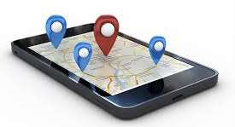

GPS (Global Positioning System) is a piece of technology that allows billions of users every day to locate themselves, their friends or their things and navigate around our world in a way we could have only dreamt of a few years ago. This innovation has progressed in a few decades from a military project to an indispensable daily resource with all manner of benefits we’ve all got used to, but also limitations we’ve learned to live with. On the plus side, your phone or your car or any other device can instantly locate where you are in the world and share that with a Geographic Information System (GIS) such as Google Maps or your car onboard system which then gives you the best route, and turn by turn directions to your destination including taking into account traffic and disruptions. On the downside, GPS is notoriously hungry for the battery it does not work indoors, and it requires an expensive chip to calculate your position as well as a data link to send the information to the Internet. There have been alternative solutions for communication standards such as Bluetooth or Wi-Fi which have proven to be quite challenging due to short-range limits of these networks and devices as well as relatively short battery life. So the ideal solution to track anything should: 1) work indoors and outdoors 2) offer a long battery life 3) have a good radio range 4) be inexpensive to set up and run 5) not require a router for every few meters.

## 5. REFERENCES

1. Michael G Wing and Aaron Eklund elaborately explained Performance Comparison of a Low- Cost Mapping Grade Global Positioning Systems (GPS) Receiver and Consumer Grade GPS Receiver under Dense Forest Canopy.
2. Michael G Wing, Aaron Eklund, and Loren D Kellogg wrote a thesis on Consumer-Grade Global Positioning System (GPS) Accuracy and Reliability.